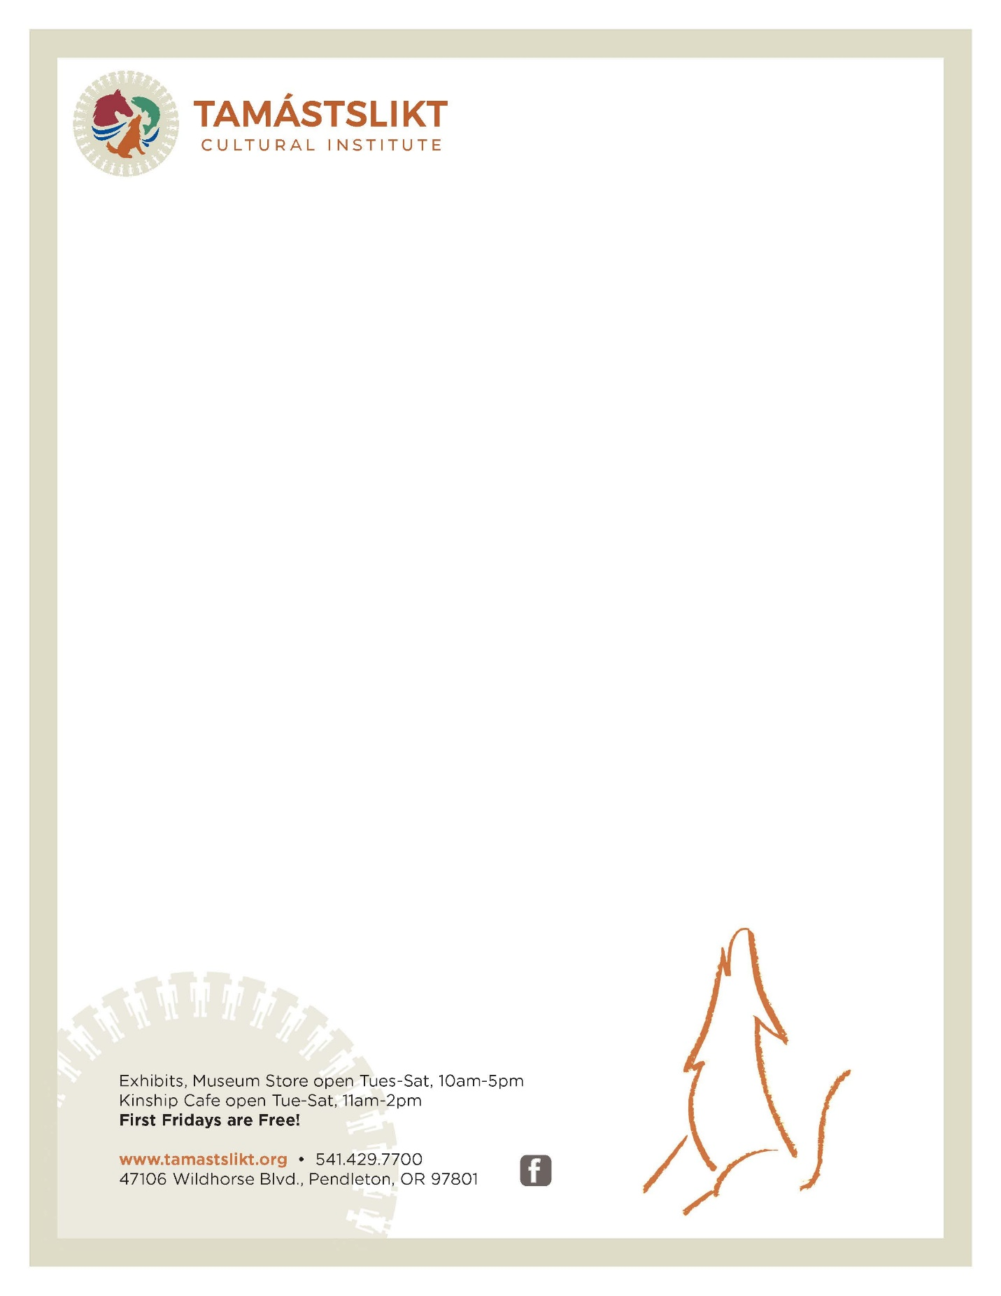

CTUIR Supplementary Contemporary Media Resources
Antone Minthorn: A Win-Win Situation - Confluence Project
Antone Minthorn: Restoration of Sovereignty and Self-Governance - Confluence Project
Antone Minthorn: In the End We Won. We Got “Fish Back in Umatilla” - Confluence Project
Antone Minthorn: Building an Economy - Confluence Project
Climate Change Strategies - CRITFC
Confederated Tribes of the Umatilla Indian Reservation Consultation
CTUIR+Vulnerability+Assessment+Technical+Report+FINAL.pdf (squarespace.com)
First foods lead the way in Confederated Tribes of the Umatilla Indian Reservation natural resource management - OPB
Getting to know Native Americans of Oregon
Grande Ronde Massacre-Oregon Encyclopedia
Indigenous Perspectives on Earth, Water, and Sky Roberta Conner
In place of a land acknowledgment, eight calls to action (ecotrust.org)
Tribal History/Shared History (Oregon Department of Education)
Umatilla Reservation Contemporary voices (Tribal Legacy Project)
Videos – Tribal Legacy Project (lc-triballegacy.org)
Walla Walla Treaty Council 1855

